brother
 Direct-to-Garment Digital Printer

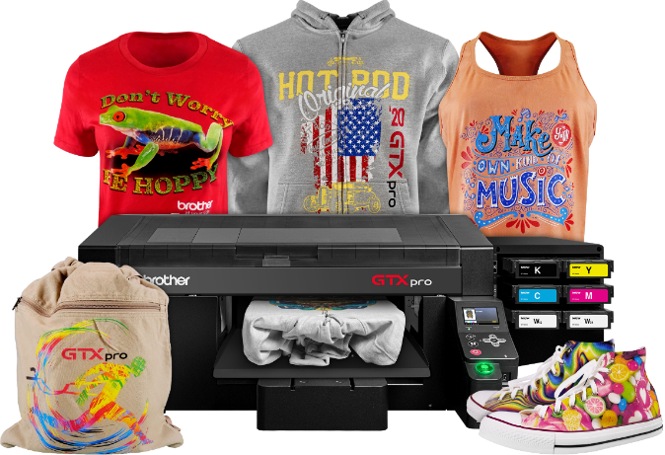
Less
Operator problems
Less
Maintenance
Less
Ink Consumption
Less
Time Needed
Easy printing on a wide variety of textiles such as trousers, shoes, caps and much more.
Compact industrial design and size suitable for all kinds of production environments.

--------------------------------------------------------------------------------------------------
 Direct-to-Garment Digital Printer

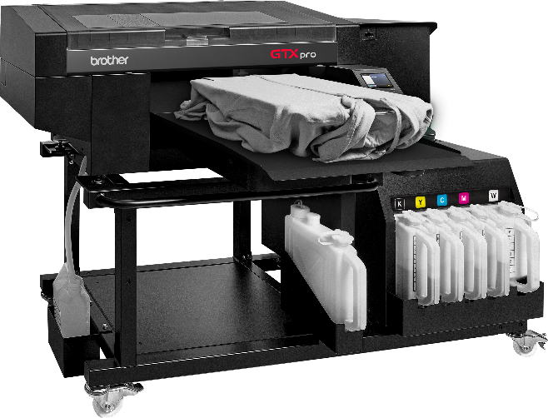
Revolutionary New Bulk Ink System
Reduced Maintenance Time
New Industrial White Print Head Design
High Speed Print Mode

